# User Guide

## Introduction

This user guide will include how to add and update assets, add owners, add asset models, and update who each asset is assigned to. It also provides an explanation to how to sort through the data, how the dropdowns work, and how to download a report based on the way you’ve sorted the information. For a detailed installation guide for the server setup, and information back up guide, refer to the table of contents to find the Setup section

## Using the Application

## *Login*

1. *The first step varies depending on if you are accessing the current live website, or if it has been installed on your local machine.*
   1. ***If you have installed this on your own machine****: Navigate to either* [*http://localhost/WGUCapstone/*](http://localhost/WGUCapstone/) *or http://<servername>/WGUCapstone/ (<servername> is replaced of course by the name or IP Address of the server which the application was installed on), and you are signed into a windows computer with the account that was provided access in the ‘Web.config’ file, you should not need to sign in to be authenticated. If you are using a device not using windows, or the login you are signed in with do not match any accounts or groups access is provided to, it will bring up a popup asking for your username and password*
   2. ***To get to the Live Site:*** *Navigate to* [*http://dakoda-willden.ddns.net/WGUCapstone*](http://dakoda-willden.ddns.net/WGUCapstone) *in a web browser. If you try to navigate to it by clicking the link, a popup will show up before opening the browser to access the website. It may pop up a couple of times before the browser opens, then another in the browser. For the login information, read the next step.*

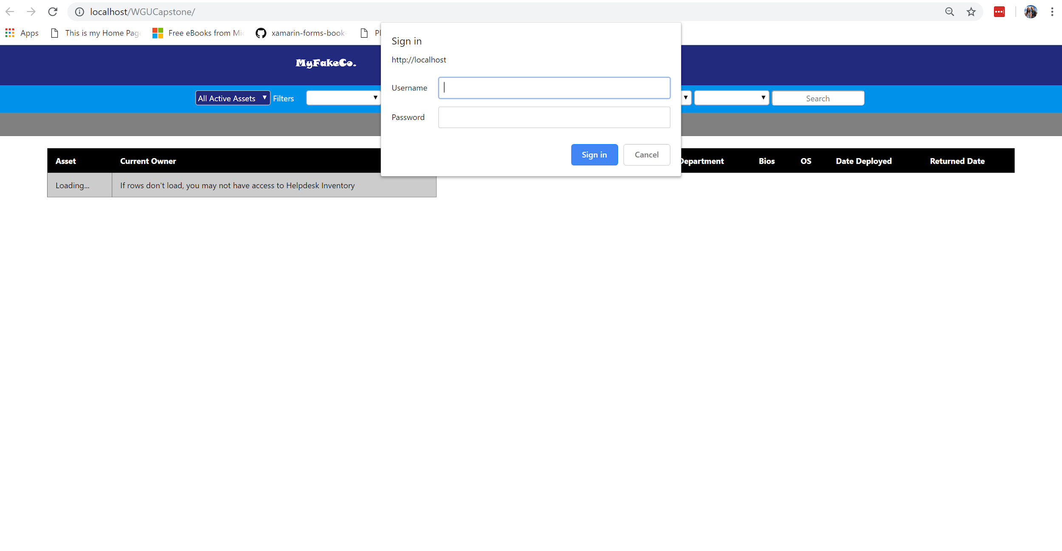

1. *You will enter a username and password. The test account that is meant for evaluation purposes has the following credentials:*
   1. **The following information is needed to access the live site:**

**username**: wgueval

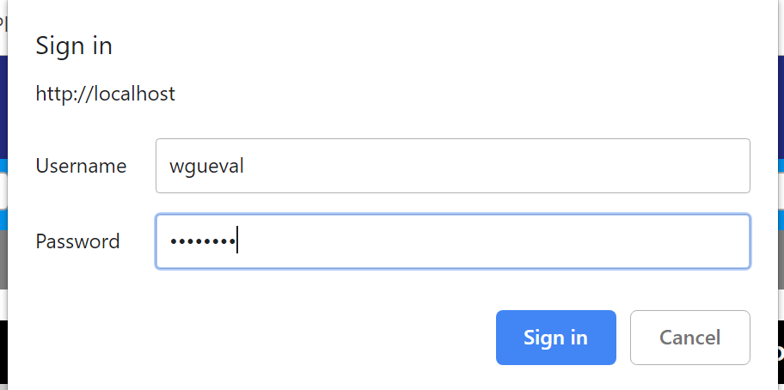 **password**: C1$gaD05

1. *After a few seconds after you have entered the given credentials, and you are logged in, it should show the following page:*

## *How to Add an Asset*

1. *Click on the green ‘Add Asset’ button in the grey bar above the table*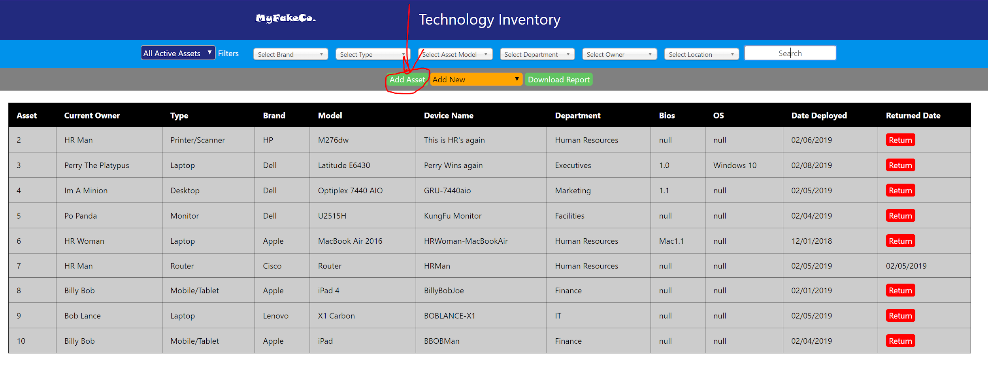
2. *A form should come up that asks you to fill in some information.*
3. 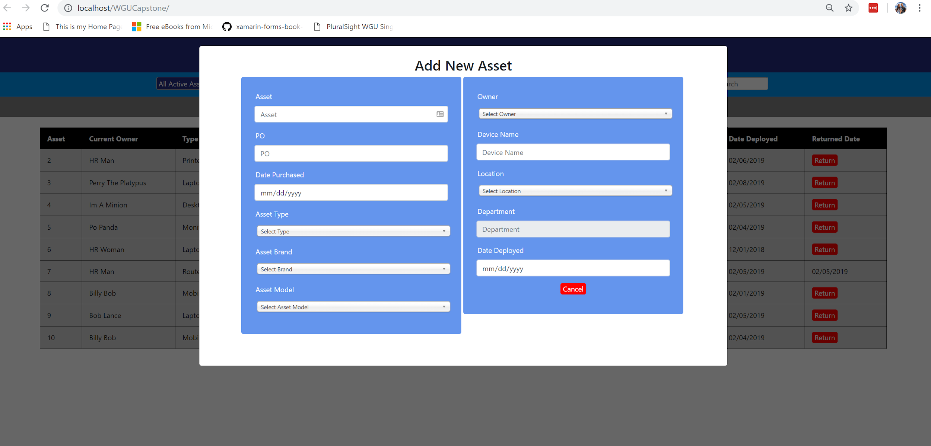*In this form, the left column is the information specific to the asset itself that doesn’t change based on assignment. The right column is the information relevant only to the current assignment. The minimum information that should be added is shown below.:*
   1. *An ‘Asset Id’*
   2. *The date the asset was purchased*
   3. *The ‘Asset Type’*
   4. *The ‘Asset Brand’*
   5. *The ‘Asset Model’ (If the ‘Asset Model’ you are wanting to add doesn’t exist, you can add a new ‘Asset Model’. The instructions are in the ‘How to Add an Asset Model’ section a few sections below this one)*
   6. *The ‘Owner’ (This indicates the person it will be checked out to. If the ‘Owner’ you are wanting to add doesn’t exist, you can add a new ‘Owner’. The instructions are in the ‘How to Add an Owner’ section a couple sections below this one)*
   7. *The ‘Device Name’*
   8. *The ‘Location’ (If it will be in the office building, or at home for use)*
   9. *The date it is being checked out (‘Date Deployed’)*
   10. *NOTE: If this information is not given, it won’t allow you to submit the form, or will alert the user that the required information isn’t entered.*
4. *Press ‘Submit’ when the required information as well as the information that you are wanting to track is included correctly in the form.*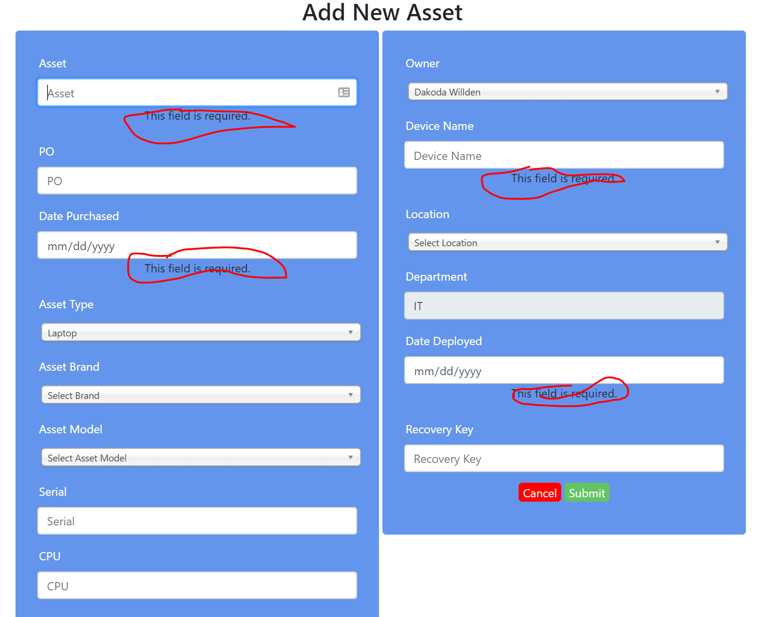
   1. *NOTE: If the asset id already exists, the form will update the asset id mentioned*
5. *The user will be alerted that the asset has been updated and will continue to an ‘Update Asset’ form. Click on the grey area, or the red cancel button to exit the form and get back to the main table.*
6. *The table should be updated with the new asset*

## *How to Update an Asset*

Here are the steps for updating an asset:

1. 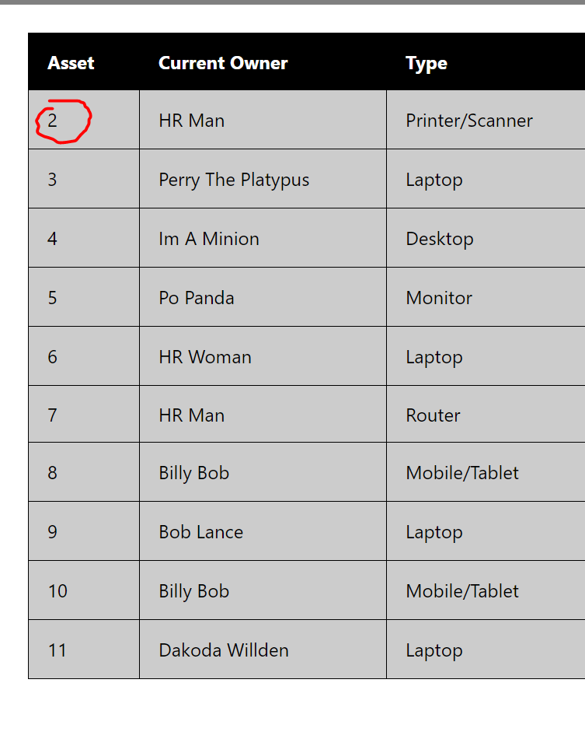Click on the ‘Asset Id’ in the table for the asset you are wanting to edit the information for, and an ‘Update Asset’ form will show up, including the information specific to the asset, or the information specific to that assignment.
2. When you click on the asset number you’re going to edit or update, a form like the Add Asset form will come up, and provide you with the information that’s currently saved, as well as the history for that specific asset. You may need to scroll down to view the history for that specific asset

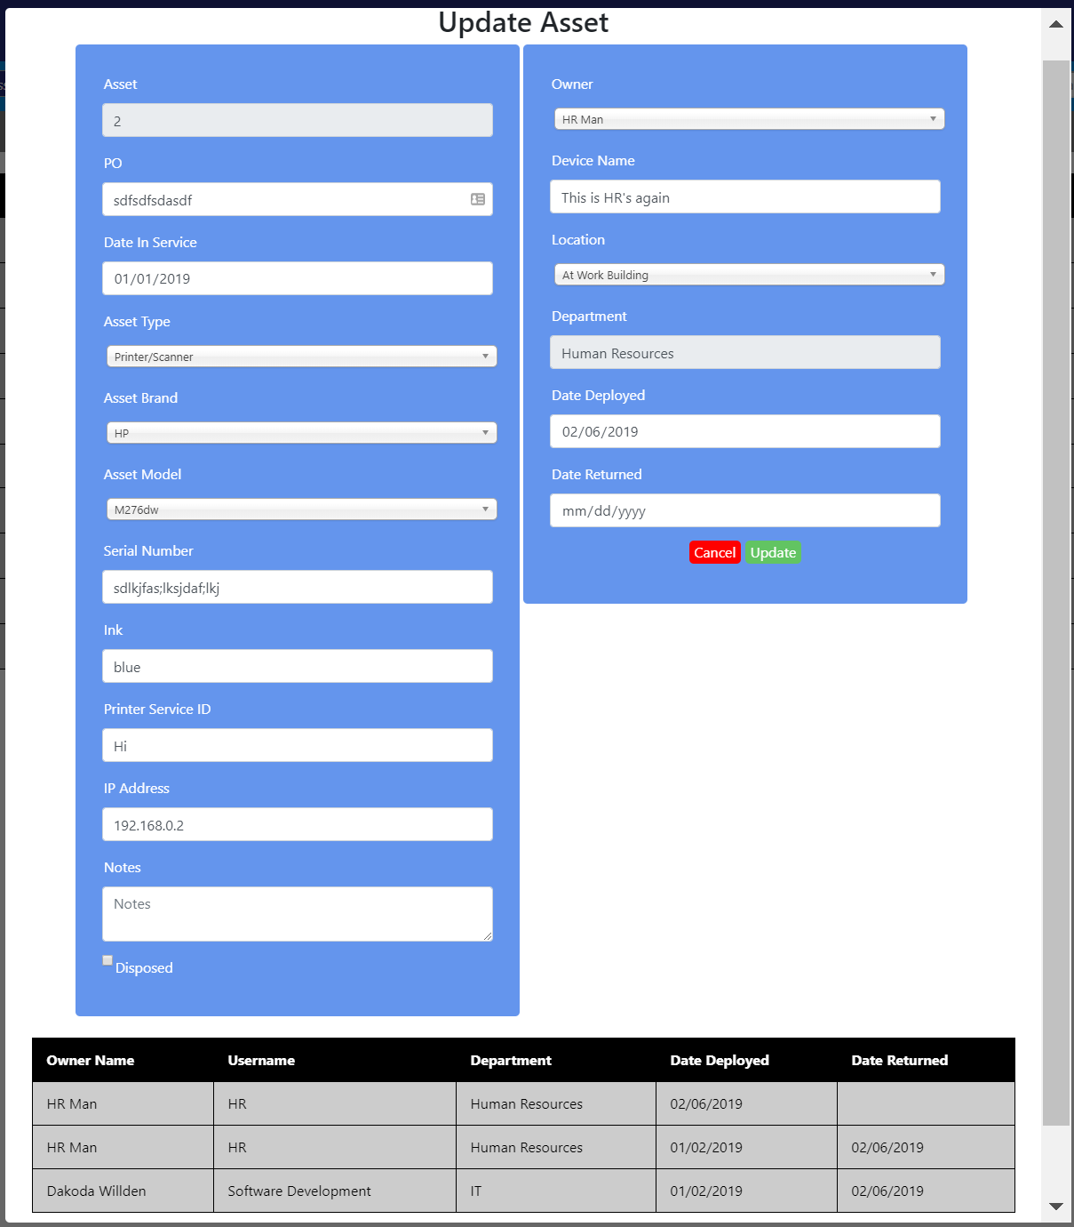

1. You can change the owner, and change the date deployed to create a new assignment, and set the old assignment to checked in, so the information in that assignment that is still quickly available would be in the history table at the bottom of the form
2. Once you change any information you are wanting to change for an asset or its current assignment, press the green update button in the form, or press enter while in any other part of the form.
3. You can choose to mark an asset as returned as well by setting the date returned value to when it was returned, and it will mark it as returned.
   1. NOTE: If you do this, in the main table, it will show the last person it was assigned to.
4. When you press the update button, it will notify you when it has been updated, and update the main table.

## *How to Add an Owner*

1. Click on the dropdown that says ‘Add New’
2. Click on the option that displays ‘Add New Owner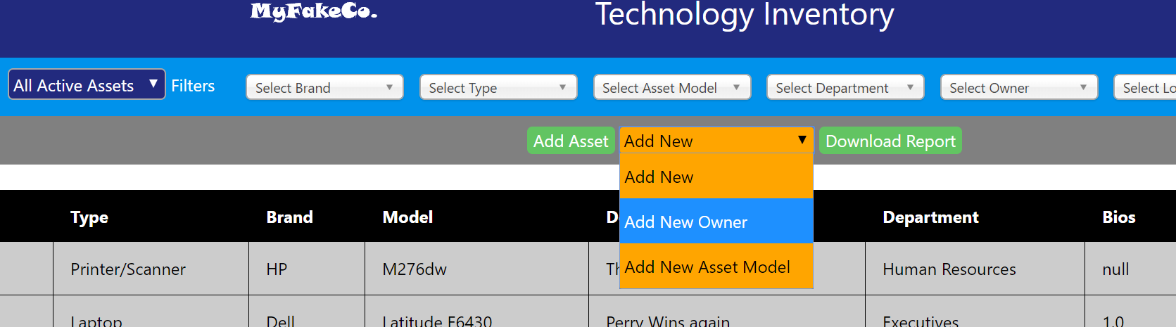’
3. A form will pop up to add information for a new owner to be added
4. Enter the owner name or location name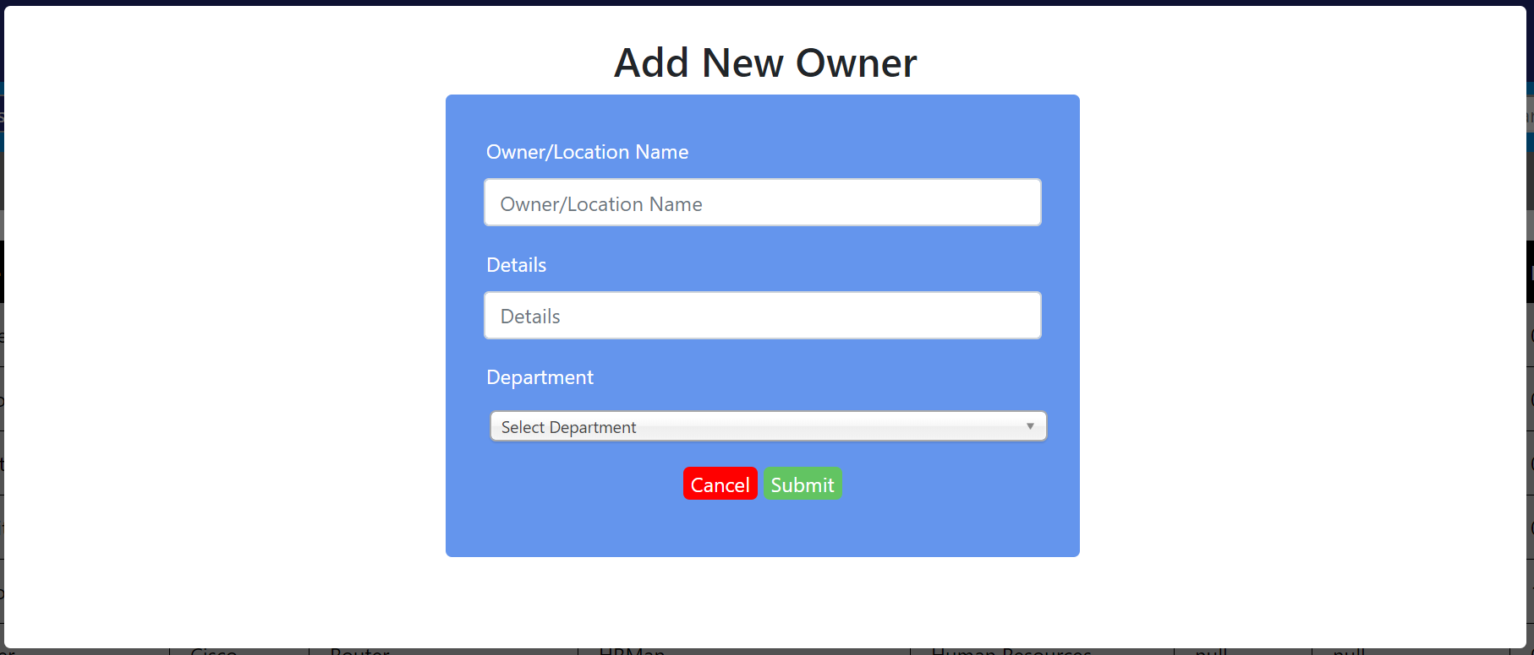.
5. Enter the username or details.
6. Select the department you want the user or location to be a part of.
7. Press the ‘Submit’ button.

## *How to Add an Asset Model*

1. Click on the dropdown that displays ‘Add New’.
2. Click on the option that says ‘Add New Asset Model’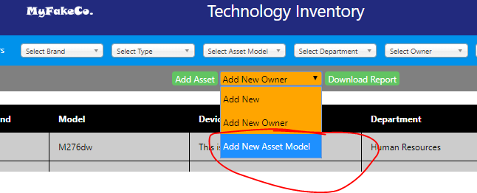.
3. A form should pop up to add a new ‘Asset Model’.
4. Enter the type and brand you want the new ‘Asset Model’ to tie to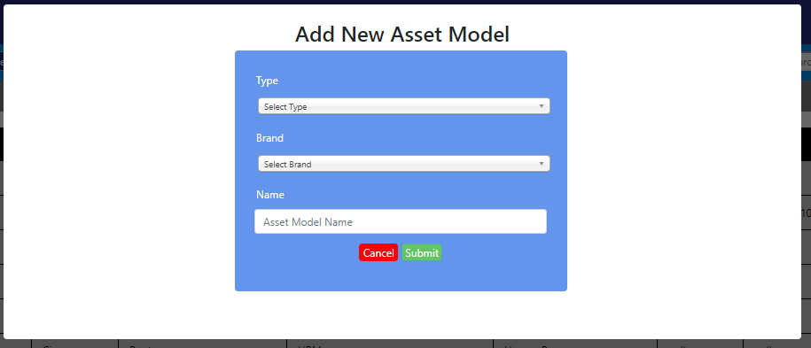.
5. Type in the new ‘Asset Model’ name.
6. Press ‘Submit’.

## *Sort the Information*

You can do a combination of dropdowns to sort what information shows up on the main table to find information that you are needing to find. I will include the options you can sort by below:

1. Brand
2. Type
3. Asset Model (Selecting brand and type dropdowns first change the options in this dropdown)
4. Department
5. Owner
6. Location
7. Search Bar

You can sort through the data using either using a combination of all the dropdowns, or through the search bar. If you have sorted it by dropdowns, and search by something more specific, the dropdowns are disregarded.

Another thing you can do with sorting, is use the dark blue dropdown. That dropdown is used to determine which subset of data we are searching through. You can search through only disposed assets, only assets that are checked in, only assets that are checked out, all assets that are active, or all assets, regardless of checkout status, or active status.

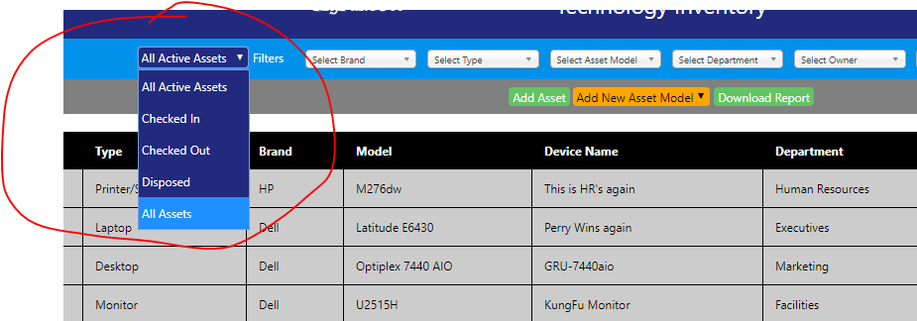

## *Download Reports*

1. To download a report, sort the information so that the table is showing what you would like for it to show.
2. Click the download report button.
3. When you press this, you will be able to download a .csv file for the report you just sorted to find